**Ministerul Educației și Cercetării al Republicii Moldova**

**Universitatea Tehnică a Moldovei**

**Facultatea Calculatoare, Informatică și Microelectronică**



Raport

Lucrarea de laborator nr. 3

Disciplina: **Analiza si proiectarea algortimilor**

Tema: **Graf de acoperire. Algoritmii Prim si Kruskal**.

|  |  |  |
| --- | --- | --- |
| **A efectuat:** | Student grupa TI-231 FR | Apareci Aurica |
| **A verificat:** | Asistent universitar | Andrievschi-Bagrin Veronica |

**Chișinău 2025**

**Cuprins**

1.Cadru teoretic 3

2. Listingul programului 4

3. Cazuri de testare 8

4. Concluzii 12

# **Cadru teoretic**

**Tema:**Algoritmi lacomi

**Sarcina (conform variantei):**Analiza și implementarea algoritmilor lacomi de căutare a grafului de acoperire de cost minim (Algoritmul lui Prim și algoritmul lu Kruskal)

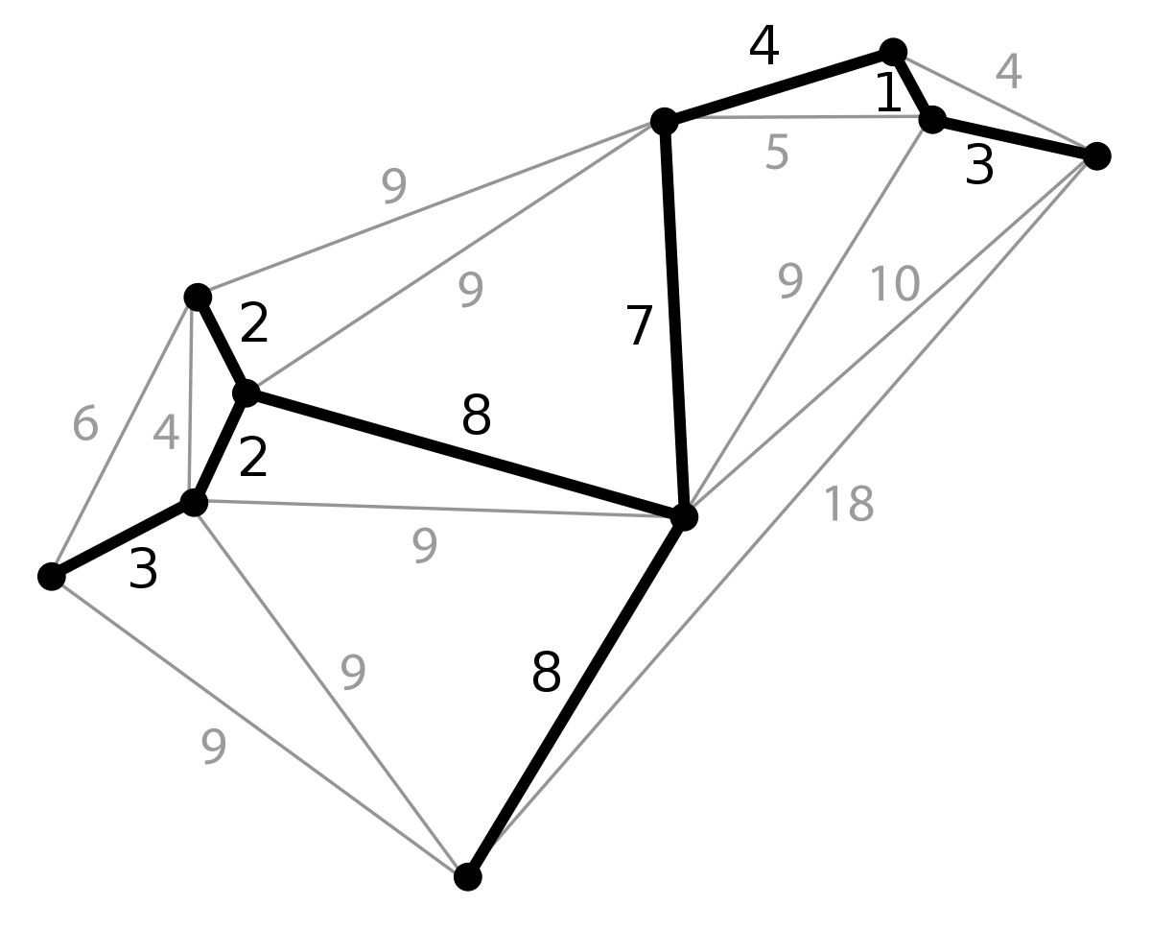

# **2. Listingul programului**

**//se utilizeaza urmatoarea biblioteca: GitHub - dotnet/BenchmarkDotNet: Powerful .NET library for benchmarking versiunea: 0.13.2**

**using BenchmarkDotNet.Running;**

**using Lab_3_utils;**

**namespace Laboratorul_3**

**{**

**class Program**

**{**

**static void Main(string[] args)**

**{**

**//run this in Release mode**

**BenchmarkRunner.Run<Benchmark>();**

**}**

**}**

**}**

**namespace Lab_3_utils**

**{**

**public class Algs**

**{**

**public static void Kruskal(Graf graph)**

**{**

**//sort edges by cost**

**graph.Muchii.Sort((x, y) => x.Cost.CompareTo(y.Cost));**

**//create disjoint sets**

**List<DisjointSet> sets = new List<DisjointSet>();**

**foreach (int node in graph.Noduri)**

**{**

**sets.Add(new DisjointSet(node));**

**}**

**//create MST**

**List<Muchie> MST = new List<Muchie>();**

**foreach (Muchie edge in graph.Muchii)**

**{**

**//find sets containing the nodes of the edge**

**DisjointSet set1 = null;**

**DisjointSet set2 = null;**

**foreach (DisjointSet set in sets)**

**{**

**if (set.Contains(edge.Start))**

**set1 = set;**

**if (set.Contains(edge.End))**

**set2 = set;**

**}**

**//if the sets are different, merge them and add the edge to the MST**

**if (set1 != set2)**

**{**

**set1.Merge(set2);**

**sets.Remove(set2);**

**MST.Add(edge);**

**}**

**}**

**//print MST**

**PrintMST(MST);**

**}**

**public static void Prim(Graf graph)**

**{**

**//create a list of edges in the MST**

**List<Muchie> MST = new List<Muchie>();**

**//create a list of visited nodes**

**List<int> visited = new List<int>();**

**//add the first node to the visited list**

**visited.Add(graph.Noduri[0]);**

**//while there are still nodes to visit**

**while (visited.Count < graph.Noduri.Count)**

**{**

**//create a list of edges that connect to visited nodes**

**List<Muchie> edges = new List<Muchie>();**

**foreach (var edge in graph.Muchii)**

**{**

**if (visited.Contains(edge.Start) && !visited.Contains(edge.End))**

**{**

**edges.Add(edge);**

**}**

**}**

**//sort the edges by cost**

**edges.Sort((x, y) => x.Cost.CompareTo(y.Cost));**

**//add the cheapest edge to the MST**

**MST.Add(edges[0]);**

**//add the new node to the visited list**

**visited.Add(edges[0].End);**

**}**

**PrintMST(MST);**

**}**

**private static void PrintMST(List<Muchie> MST)**

**{**

**Console.WriteLine("MST:");**

**foreach (var edge in MST)**

**{**

**Console.WriteLine(edge);**

**}**

**}**

**}**

**}**

**using BenchmarkDotNet.Attributes;**

**namespace Lab_3_utils**

**{**

**[MemoryDiagnoser]**

**public class Benchmark**

**{**

**Graf Graph { get; set; }**

**[GlobalSetup]**

**public void Setup()**

**{**

**//Graph = GraphGenerator.Defav(500);**

**//Graph = GraphGenerator.Fav(500);**

**Graph = GraphGenerator.Med(500);**

**}**

**[Benchmark]**

**public void Prims()**

**{**

**Algs.Prim(Graph);**

**}**

**[Benchmark]**

**public void Kruskal()**

**{**

**Algs.Kruskal(Graph);**

**}**

**}**

**}**

**namespace Lab_3_utils**

**{**

**public class DisjointSet**

**{**

**public List<int> Nodes { get; set; }**

**public DisjointSet(int node)**

**{**

**Nodes = new List<int>();**

**Nodes.Add(node);**

**}**

**public bool Contains(int node)**

**{**

**return Nodes.Contains(node);**

**}**

**public void Merge(DisjointSet set)**

**{**

**Nodes.AddRange(set.Nodes);**

**}**

**}**

**}**

**namespace Lab_3_utils**

**{**

**public class Graf**

**{**

**public List<int> Noduri { get; set; }**

**public List<Muchie> Muchii { get; set; }**

**public Graf()**

**{**

**Noduri = new List<int>();**

**Muchii = new List<Muchie>();**

**}**

**public void LoadGraph(int[,] arr)**

**{**

**for (int i = 0; i < arr.GetLength(0); i++)**

**{**

**for (int j = 0; j < arr.GetLength(1); j++)**

**{**

**if (arr[i, j] != 0)**

**{**

**if (!Noduri.Contains(i))**

**Noduri.Add(i);**

**if (!Noduri.Contains(j))**

**Noduri.Add(j);**

**Muchii.Add(new Muchie(i, j, arr[i, j]));**

**}**

**}**

**}**

**}**

**public int[,] ToMatrix()**

**{**

**int[,] arr = new int[Noduri.Count, Noduri.Count];**

**foreach (var muchie in Muchii)**

**{**

**arr[muchie.Start, muchie.End] = muchie.Cost;**

**}**

**return arr;**

**}**

**public static int[,] ReadFromFile(string path)**

**{**

**StreamReader rd = new StreamReader(path);**

**string line = rd.ReadLine();**

**int n = int.Parse(line.Split(' ')[0]);**

**int v = int.Parse(line.Split(' ')[1]);**

**int[,] arr = new int[n+1,n+1];**

**for (int i = 0; i < v; i++)**

**{**

**line = rd.ReadLine();**

**int start = int.Parse(line.Split(' ')[0]);**

**int end = int.Parse(line.Split(' ')[1]);**

**int cost = int.Parse(line.Split(' ')[2]);**

**arr[start, end] = cost;**

**}**

**return arr;**

**}**

**}**

**namespace Lab_3_utils**

**{**

**public class GraphGenerator**

**{**

**//mode:**

**//fav - 1 - graph with n-1 edges**

**//med - 2 - graph with n(n-1)/4**

**//defav - 3 - graph with n(n-1)/2**

**public static Graf Fav(int nodes)**

**{**

**//generates a graph with n nodes and n-1 edges of random cost**

**Graf graph = new Graf();**

**Random rnd = new Random();**

**for (int i = 0; i < nodes; i++)**

**{**

**graph.Noduri.Add(i);**

**}**

**for (int i = 0; i < nodes - 1; i++)**

**{**

**graph.Muchii.Add(new Muchie(i, i + 1, rnd.Next(1, 100)));**

**}**

**return graph;**

**}**

**public static Graf Med(int nodes)**

**{**

**//generates a graph with n nodes and n(n-1)/4 edges of random cost**

**Graf graph = new Graf();**

**Random rnd = new Random();**

**for (int i = 0; i < nodes; i++)**

**{**

**graph.Noduri.Add(i);**

**}**

**for (int i = 0; i < nodes; i++)**

**{**

**for (int j = i + 1; j < nodes; j++)**

**{**

**if (rnd.Next(0, 2) == 1)// 50% chance of adding an edge**

**graph.Muchii.Add(new Muchie(i, j, rnd.Next(1, 100)));**

**}**

**}**

**return graph;**

**}public static Graf Defav(int nodes)**

**{**

**//generates a graph with n nodes and n(n-1)/2 edges of random cost**

**Graf graph = new Graf();**

**Random rnd = new Random();**

**for (int i = 0; i < nodes; i++)**

**{**

**graph.Noduri.Add(i);**

**}**

**for (int i = 0; i < nodes; i++)**

**{**

**for (int j = i + 1; j < nodes; j++)**

**{**

**graph.Muchii.Add(new Muchie(i, j, rnd.Next(1, 100)));**

**}**

**}**

**return graph;**

**}**

**}**

**}**

**namespace Lab_3_utils**

**{**

**public class Muchie:IComparable<Muchie>**

**{**

**public int Start { get; set; }**

**public int End { get; set; }**

**public int Cost { get; set; }**

**public Muchie(int start, int end, int cost)**

**{**

**Start = start;**

**End = end;**

**Cost = cost;**

**}**

**public override string ToString()**

**{**

**return $"({Start},{End})\t{Cost}";**

**}**

**public int CompareTo(Muchie? other)**

**{**

**if (other == null)**

**return 1;**

**else**

**return this.Cost.CompareTo(other.Cost);**

**}**

**}**

**}**

# **3. Cazuri de testare**

N – Numărul de noduri in graf

V – Numărul de muchii din care este alcătuit graful

1 – cazul favorabil – graful generat unde V = *n - 1*

2 – cazul mediu – graful generat unde V = *n(n-1)/4*

3 – cazul defavorabil – graful generat unde V = *n(n-1)/2*

**Tabelul valorilor obtinute**

|  |  |  |  |  |  |  |
| --- | --- | --- | --- | --- | --- | --- |
| **Favorabil** | | | | | | |
|  | 100 | 200 | 300 | 350 | 400 | 500 |
| Prim | 9.007 | 20.07 | 29.62 | 31.43 | 36.95 | 45.97 |
| Kruskal | 9.041 | 19.87 | 29.42 | 31.8 | 36.42 | 45.27 |

|  |  |  |  |  |  |  |
| --- | --- | --- | --- | --- | --- | --- |
| **Mediu** | | | | | | |
|  | 100 | 200 | 300 | 350 | 400 | 500 |
| Prim | 9.477 | NAN | 264.56 | 445.49 | 726.62 | 1,640.29 |
| Kruskal | 9.201 | 19.72 | 29.86 | 32.09 | 37.13 | 46.61 |

|  |  |  |  |  |  |  |
| --- | --- | --- | --- | --- | --- | --- |
| **Defavorabil** | | | | | | |
|  | 100 | 200 | 300 | 350 | 400 | 500 |
| Prim | 9.007 | 122.21 | 526.93 | 887.14 | 1,499.09 | 3,385.42 |
| Kruskal | 9.041 | 20.44 | 29.62 | 32.3 | 39.05 | 45.96 |

**Analiza valorilor obtinute**

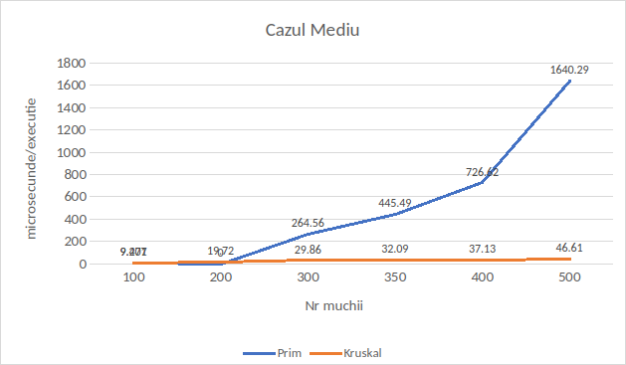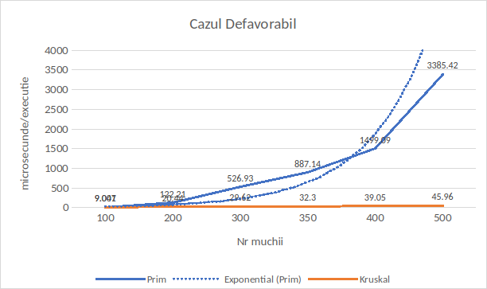

# **4. Concluzii**

In cadrul acestei lucrări de laborator am efectuat analiza eficientei de determinare a grafului de acoperire de cost minim pentru algoritmul lui Prim si algoritmul lui Kruskal. Aceste doua algoritme prezinta o abordare lacoma asupra generării soluției problemei și urmează sa prezinte un timp de execuție strict dependent de natura setului de date de intrare generat pentru testare. Tind sa menționez ca generatorul de grafuri care urmează sa creeze seturile de intrare trebuie bine formulat, iar algoritmul care sta la baza acestuia trebuie sa asigure condiții egale de generare pentru ambele algoritme testate. Deși in aceasta lucrare am preferat sa fac o analiza asupra timpului de execuție a algoritmului in loc de numărul de iterații/operații efectuate de fiecare implementare a algoritmilor, consider ca m-am descurcat cu proiectarea generatorului de grafuri cat si cu efectuarea unei analize obiective pentru fiecare din algoritmii propuși. Un accent foarte important trebuie pus pe generatorul de grafuri deoarece acesta este cheia către o analiza corecta. In urma analizei câtorva seturi de rezultate dar si a codurilor sursa ce aparțin colegilor de grupa, am fost capabil sa găsesc anumite erori in codul colegilor, dar si sa-mi confirm corectitudinea analizei efectuate pe baza timpului de execuție in comparație cu analiza colegilor efectuata pe numărul de iterații. Tot o data doresc sa menționez neclaritatea condiției acestui laborator si anume metodele de stocare a grafurilor in memoria calculatorului, lucru ce urmează sa influențeze direct la efectuarea analizei obiective. In final consider ca am efectuat o analiza obiectiva a celor doi algoritmi propuși si mi-am făcut concluziile personale ce urmează sa fie aplicate in viitoarele proiecte cu care o sa lucrez.